Record at Home with Radio Eye!

What you'll need :
1. An iPad, iPhone, or Android phone or tablet.
2. Audio Memos Standard (Available in your App Store for just $1!)
3. A quiet room
4. A headset (This is optional but can be purchased for around $15)
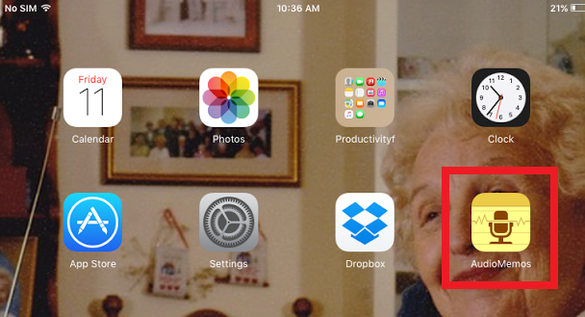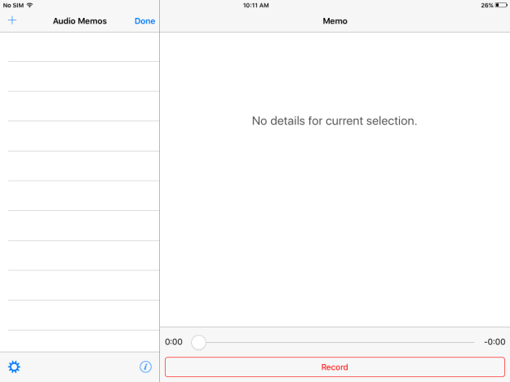

How it works:
- You'll record a broadcast on your own at home using the Audio Memos App to record and then simply send it to Lucy at Radio Eye using DropBox!
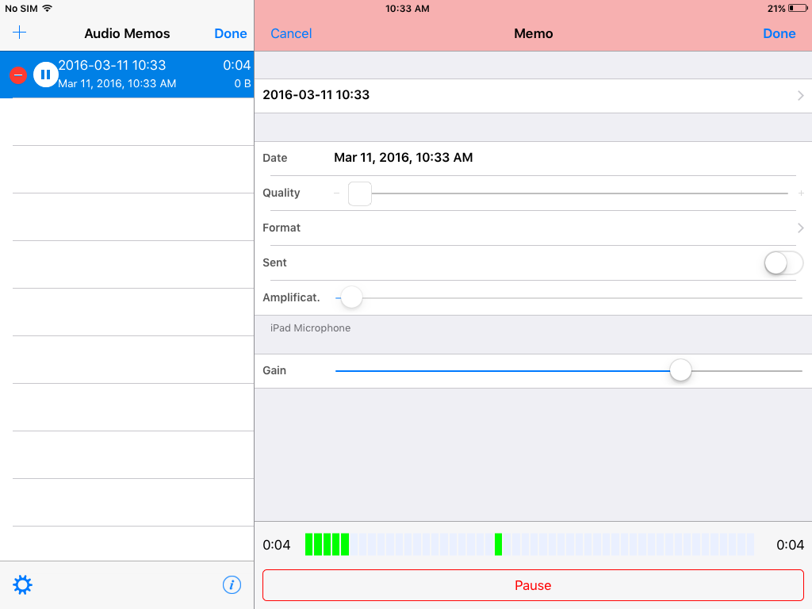

- The broadcast needs to be saved using a .wav file instead of a mp4 file.
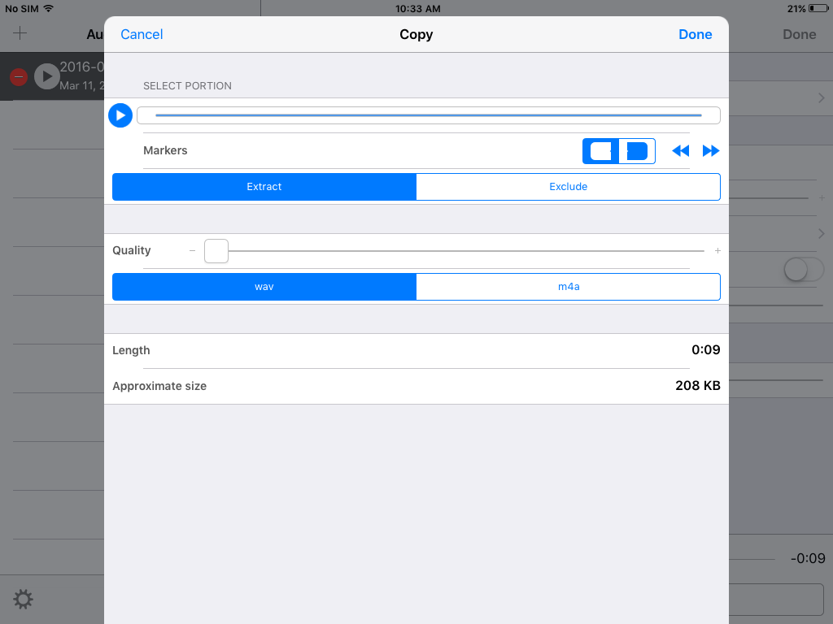
- DropBox is the easiest way to send the file and for us to receive it. DropBox does need to be downloaded on the recording device but it is a free app and very easy to use!
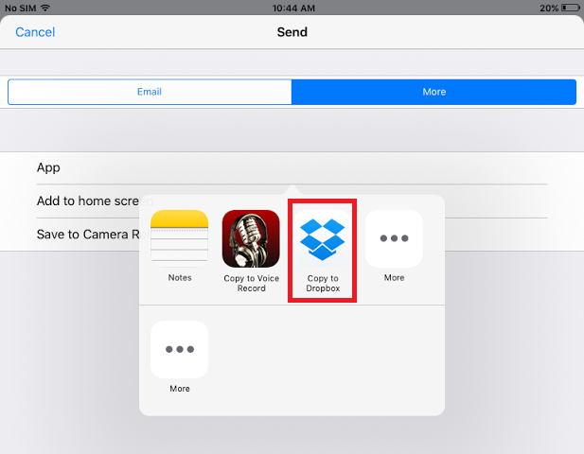
- You'll have to monitor your time spent reading but the recording time use is easy to see and straightforward on the app.
- It is possible to record over mistakes! Lucy would be happy to show you how!
- As of right now, we've only been experimenting using Apple products. If you have an Android device and are still interested in Recording at Home, please see Lucy and you can tackle the adventure together!

